The National Women’s Team was selected on 29 October and is due to tour to Gauteng on 8 January to 14 January 2017, where they will play a series of friendly games against Gauteng Women’s side and Northerns Women’s. The Team is determined to prepare properly for and to participate and to be competitive in The African Women’s T20 Qualifying during November 2017.

Women’s team selected for Gauteng Tour - January 2017
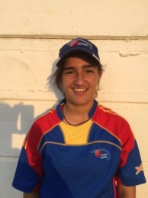
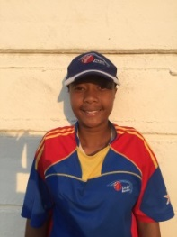
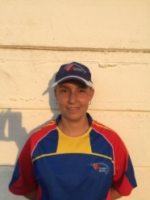

Petro Enright Eveleen Ketjarukua Yasmeen Khan Phia Gerber Marelise Jacobs
Top order batsman Bowler /Lower order Top order batsman Top order batsman Leg spinner/lower order
Bowler Batsman Bowler Batsman

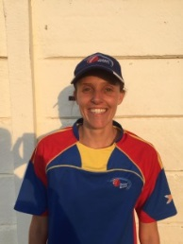
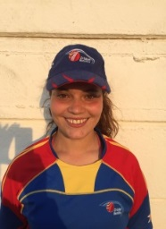

Hannelise De Klerk Rene Schulze Reehana Khan Carmen Engelbrecht Kayleen Green
Middle order batsman Bowler/lower order Bowler/lower order Wicket keeper/middle Off spinner/middle order
Bowler Batsman Batsman Order batsman batsman.

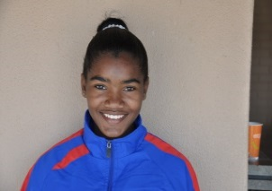
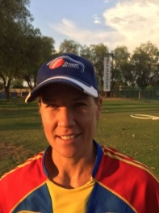

Didi Foerster Irene Van Zyl Arrasta Diergaardt Adri Van Der Merwe
Lower order batsman Top order batsman All Rounder Middle order batsman
Bowler

FIXTURES :

09h00 10 JANUARY - GAUTENG vers NAMIBIA 50 OVERS - RANDBURG CC

09h00 11 JANUARY - GAUTENG vers NAMIBIA T 20 - RANDBURG CC

14h00 11 JANUARY - GAUTENG vers NAMIBIA T20 - RANDBURG CC

09h00 12 JANUARY - NORTHENS vers NAMIBIA 50 OVERS - SINNOVILLE CC

09h00 13 JANUARY - NORTERNS vers NAMIBIA T20 - SINNOVILLE CC

14h00 13 JANUARY - NORTERNS vers NAMIBIA T20 - SINNOVILLE CC

